LABORATORY REPORT ‘e/m Experiment’
- (One-two paragraphs) Write a brief history of the experiment and explain the significance of calculating e/m ratio.

- Describe the apparatus and its principle of operation.

- Experimental data

Data Table 1
V=__________
 | Current I (A) | Diameter (m)
1
2
3
4
5
6
7

Data Table 2
V=__________
 | Current I (A) | Diameter (m)
1
2
3
4
5
6
7

- Calculation Table (You can find the calculation procedure in the video lecture from March 25)

Example:

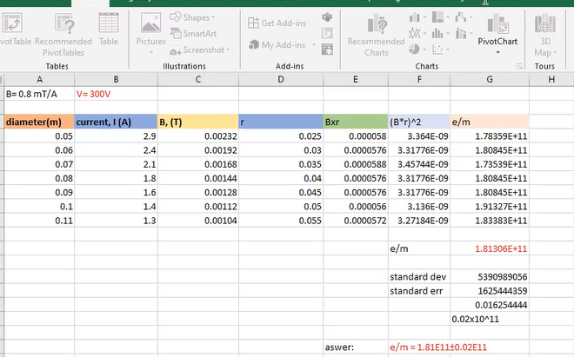

- Error analysis:

Standard deviation: __________________________

Standard error: ______________________________

- Result:

e/m = _______________± _____________________ C / kg

